## **AlexNet**

### **Introduction**

AlexNet is a deep convolutional neural network (CNN) that transformed the field of computer vision by winning the ILSVRC 2012 (ImageNet Large Scale Visual Recognition Challenge) with a top-5 error rate of 15.3%—a dramatic improvement over traditional machine learning methods.Developed by Alex Krizhevsky and Geoffrey Hinton, this model popularized the use of deep learning for large-scale image recognition, paving the way for modern deep learning architectures like VGG, ResNet, and EfficientNet.

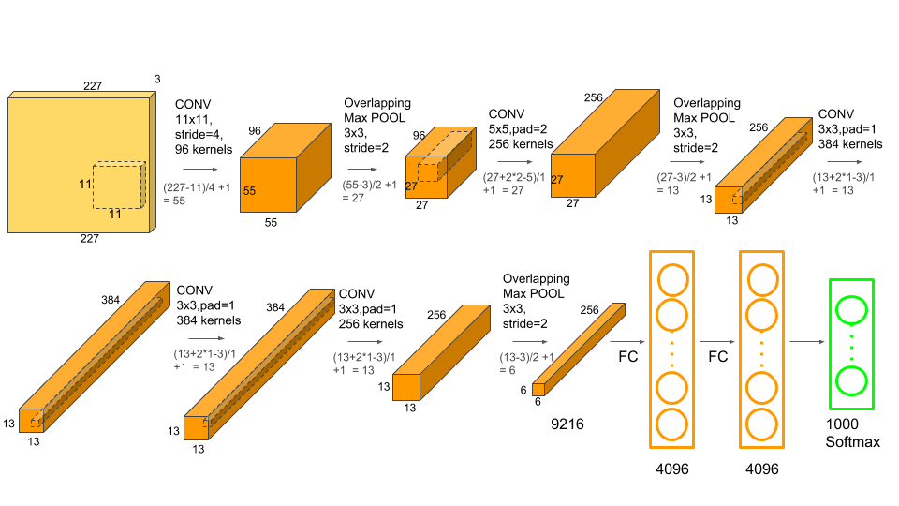

### AlexNet consists of 8 layers:

### 5 Convolutional Layers for feature extraction

### 3 Fully Connected Layers for classification

### Uses ReLU activation, Max Pooling, Dropout, and a Softmax output layer

### Performance and Impact

The AlexNet architecture dominated in 2012 by achieving a top-5 error rate of 15.3%, significantly lower than the runner-up’s 26.2%.

This large reduction in error rate excited the researchers with the untapped potential of deep neural networks in handling large image datasets. Subsequently, various Deep Learning models were developed later.

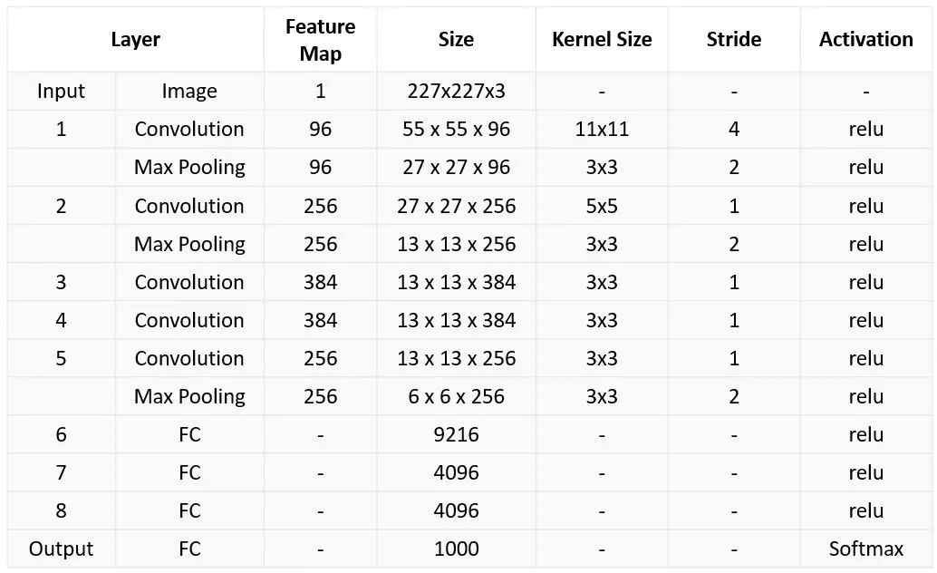

Applications of AlexNet

Developers created AlexNet for image classification. However, advances in its architecture and transfer learning (a technique where a model trained on one task is repurposed for a novel related task) opened up a new set of possibilities for AlexNet. Moreover, its convolutional layers form the foundation for object detection models such as Fast R-CNN and Faster R-CNN, and professionals have utilized them in fields like autonomous driving and surveillance.

* **Autism Detection:** Gazal and their team developed a model using transfer learning, for early detection of autism in children. The model was first trained on ImageNet and then the pre-trained model was further trained on their dataset related to autism.
* **Video Classification:** For video classification, researchers have used AlexNet to extract critical features in videos for action recognition and event classification.
* **Agriculture**: AlexNet analyzes images to recognize the health and condition of plants, empowering farmers to take timely measures that improve crop yield and quality. Additionally, researchers have employed AlexNet for plant stress detection and weed and pest identification.
* **Disaster Management**: Rescue teams use the model for disaster assessment and making emergency relief decisions using images from satellites and drones.
* **Medical Images:** Doctors utilize AlexNet to diagnose various medical conditions. For example, they use it to analyze X-rays, MRIs (particularly brain MRIs), and CT scans for disease detection, including various types of cancers and organ-specific illnesses. Additionally, AlexNet assists in diagnosing and monitoring eye diseases by analyzing retinal images.

## **Impact of AlexNet on Deep Learning**

* Inspired architectures like VGG, ResNet, Inception, EfficientNet.
* Popularized deep CNNs for image recognition.
* Demonstrated GPU-based training could scale deep learning.
* Opened doors for AI breakthroughs in medical imaging, self-driving cars, and robotics.

### 

### 

### **VGGNET**

### **Introduction**

VGG (Visual Geometry Group) Net is a deep convolutional neural network (CNN) developed by Karen Simonyan and Andrew Zisserman at the University of Oxford. It was introduced in the research paper:  
 **"Very Deep Convolutional Networks for Large-Scale Image Recognition" (2014)**

VGGNet was a breakthrough in deep learning and became one of the most widely used architectures for image classification and feature extraction. It secured second place in the ILSVRC-2014 (ImageNet Large Scale Visual Recognition Challenge), following GoogLeNet (Inception v1).

**Architecture of VGG-16:**

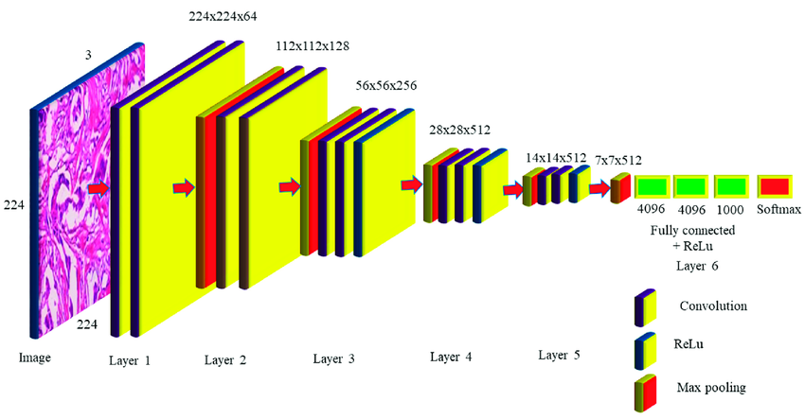

***VGG comes in different variants, such as:***  
 🔹 VGG-11 (8 conv layers)  
 🔹 VGG-13 (10 conv layers)  
 🔹 VGG-16 (13 conv layers)  
 🔹 VGG-19 (16 conv layers)

The most popular ones are VGG-16 and VGG-19.

### **VGG-16 Architecture**

VGG-16 consists of 16 weight layers:

* 13 convolutional layers (3×3 filters, stride 1, padding 1)
* 5 max-pooling layers (2×2 filters, stride 2)
* 3 fully connected (FC) layers
* Softmax activation for classification

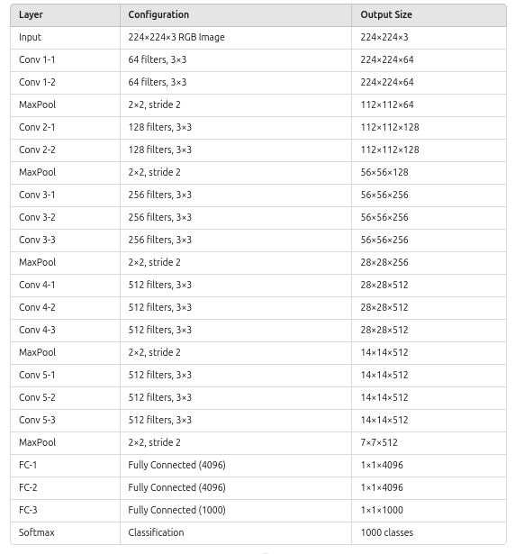

## 

## **Why Was VGGNet Important?**

Before VGG, networks like AlexNet (2012) had only 8 layers (5 convolutional + 3 fully connected). Researchers wondered:

### **Key Innovations of VGGNet**

* Very deep architecture – Up to 19 layers, compared to AlexNet’s 8.
* Small 3×3 convolutions – Instead of large filters (e.g., 5×5 or 7×7).
* More parameters but better accuracy – More layers improved performance.
* Uniform architecture – Simplicity made it easy to implement and modify.

### **Applications of VGGNet**

1️**Image Classification** – Used in medical image classification, plant disease detection, and more.

2️**Feature Extraction & Transfer Learning** – Helps in face recognition, autonomous driving, and deep learning models.

3️**Object Detection & Localization** – Powers R-CNN, YOLO, and Faster R-CNN for security and self-driving cars.

4️ **Medical Image Analysis** – Detects diseases in X-rays, MRI scans, and histopathology images.

5️ **Facial Recognition & Biometrics** – Used in security systems, phone authentication, and attendance tracking.

6️ **Style Transfer & Image Generation** – Converts photos into artistic styles using Neural Style Transfer (NST).

7️ **Image Captioning & AI Assistants** – Generates text descriptions for images in AI-powered tools.

8️ **Video Analysis & Action Recognition** – Used in sports analytics and surveillance systems.

9️ **Satellite & Aerial Image Processing** – Helps in urban planning, disaster detection, and deforestation tracking.

**GoogLeNet**

### **Introduction**

GoogLeNet, also known as Inception v1, is a deep convolutional neural network (CNN) developed by Christian Szegedy et al. from Google. It won the ILSVRC 2014 (ImageNet Large Scale Visual Recognition Challenge) by achieving a top-5 error rate of 6.67%, significantly outperforming AlexNet and VGGNet while using fewer parameters.

## **GoogLeNet Architecture**

## GoogLeNet consists of **nine Inception modules**, interspersed with **max-pooling layers** and auxiliary classifiers.

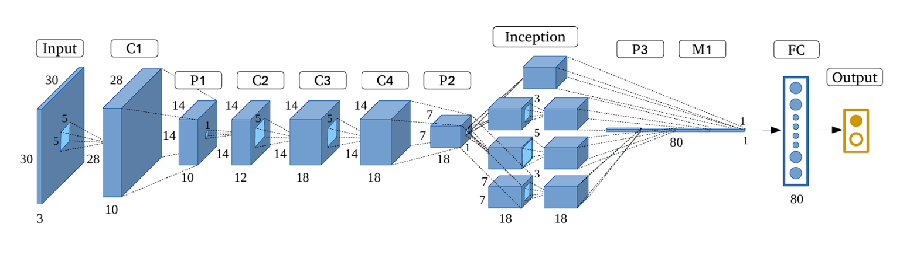

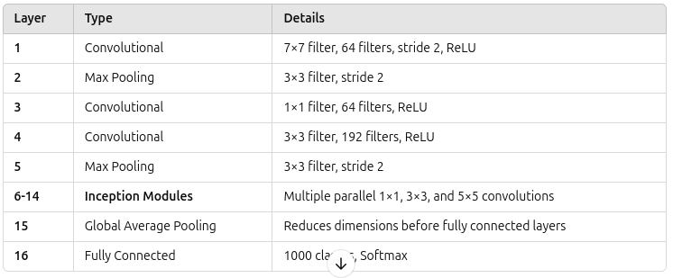

## **The Inception Module - The Heart of GoogLeNet**

The Inception module is the key innovation in GoogLeNet. Instead of using a single convolutional layer at each stage, it processes multiple receptive fields in parallel using:

* 1×1 Convolutions – Reduce dimensions before expensive operations.
* 3×3 Convolutions – Capture fine details.
* 5×5 Convolutions – Capture broader spatial features.
* Max Pooling (3×3) – Reduce feature map size while preserving information.

This allows the network to "see" features at different scales simultaneously.

**Auxiliary Classifiers to Combat Vanishing Gradients**

* Since deep networks suffer from vanishing gradients, GoogLeNet introduced two auxiliary classifiers at intermediate layers.
* These help gradients flow backward and improve training.
* Each auxiliary classifier consists of:
  + 1×1 convolution
  + Fully connected layers
  + Softmax activation
  + Used only during training (removed during inference).

**Global Average Pooling Instead of Fully Connected Layers**

* Traditional CNNs used **fully connected (FC) layers**, which **increase parameters** and cause overfitting.
* GoogLeNet replaced FC layers with **Global Average Pooling (GAP)**:
  + Instead of flattening feature maps into a vector, GAP **averages the entire feature map**.
  + This reduces **overfitting** and **improves generalization**.

**GoogLeNet Variants**

**Inception v2 (2015):** The second version of Inception included improvements such as batch normalization and shortcut connections. It also refined the inception modules by replacing larger convolutions with smaller, more efficient ones. These changes improved accuracy and reduced training time.

**Inception v3 (2015):** The v3 model further refined Inception v2 by using atrous convolution (dilated convolutions that expand the network’s receptive field without sacrificing resolution and significantly increasing network parameters).

**Inception v4, Inception-ResNet v2 (2016):** This version of Inception introduced residual connections (inspired by ResNet) into the Inception lineage, which led to further performance improvements.

**Xception (2017):** Xception replaced Inception modules with depth-wise separable convolutions

**MobileNet (2017):** This architecture is for mobile and embedded devices. The network uses depth-wise separable convolutions and linear bottleneck layers.

**EfficientNet (2019):** This is a family of models that scales both model size and accuracy strategically by using Neural Architecture Search (NAS).

**Convolutional Neural Networks Models**

### **1. Mobile and Efficient Architectures (2017–2018)**

As deep learning expanded to mobile and edge devices, researchers prioritized model compression and computational efficiency.

* **MobileNets (2017)**
  + Introduced depthwise separable convolutions to reduce computation.
  + Variants: MobileNetV2 (2018) with inverted residuals and linear bottlenecks, MobileNetV3 (2019) optimized via NAS.
* **ShuffleNet (2017, 2018)**
  + Used group convolutions and channel shuffling to improve efficiency for mobile devices.

### **2. Attention Mechanisms and Enhanced Feature Learning (2018–2020)**

CNNs incorporated attention-based modules to focus on important spatial and channel features.

* **SENet (2018, Squeeze-and-Excitation Networks)**
  + Used channel attention to recalibrate feature maps dynamically, winning the ILSVRC 2017 challenge.
* **EfficientNet (2019)**
  + Introduced compound scaling (width, depth, and resolution) to optimize model efficiency.
  + Later extended to EfficientNetV2 (2021) with improved training efficiency.
* **RegNet (2020)**
  + Explored network design space using neural architecture search (NAS).

### **3. CNN-Transformer Hybrids and New Architectures (2020–2022)**

Transformers influenced CNN evolution, leading to hybrid architectures.

* **ResNeSt (2020)**
  + Introduced split-attention blocks to improve feature representation.
* **ConvNeXt (2022)**
  + A modernized CNN architecture designed to match the performance of Vision Transformers (ViTs) while keeping the convolutional paradigm.

### **4. Transformer Dominance and CNN Refinements (2023–Present)**

With Vision Transformers (ViTs) taking over, CNNs are being adapted or hybridized.

* **EfficientNetV2 (2021)**
  + Optimized training efficiency while maintaining high accuracy.
* **ConvFormer (2023)**
  + Combines convolutional efficiency with transformer-style attention mechanisms.